11/16/16 Assembly

Class Notes

Overview:

* Finish up floating points

Next week:

* Mlk lab for hardware
* Use wiringPi library to wire it

Delays

* Ex)

Delay(1000)

Ldr r0, #1000

Bl delay

* Must use ldr if value is greater than 8 bytes

Super scalar programming

* Pipelines
* Simd
  + Signal instruction multiple data
  + Ex)

.data:

X: .word 1,3,8,10

Y: . word 3,4,7,9

//Registers

R registers – 32 bits

S – 32 bit floats

D – 64 bit floats

* + Data is transferred from both variables simultaneously
    - Parallel computing

Neon instructions

Type casting

* Ex)
  + 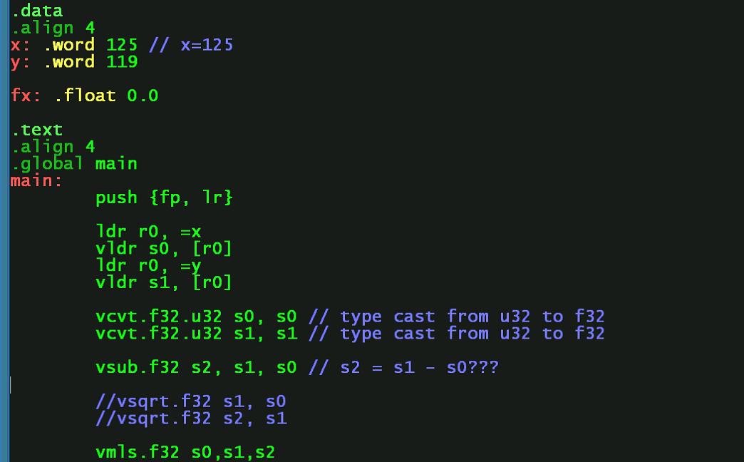

Penalties of raspberry pi

* Read after write delay
  + Ex)
    - Ldr r0, =x

Ldr r0, [r0]

* + R0 cannot store the value without reading x first